

**TEAM**

Our Team members are: Bek Zhaksybai, Malika Balabekova, Aruzhan Baizakova, Ainur Karimbayeva and Meruert Nassirdinova.

Bek Zhaksybay is responsible for making about page. During the work he took the role of psychologist as well and supported us for keeping our mood positive.

Malika Balabekova and Ainur Karimbayeva are responsible for home page. Malika always tried to keep our atmosphere humorous.

Meruert Nassirdinova made our JavaScript.

And Aruzhan Baizakova is responsible for documentation and meetings.

**COMMUNICATION STRATEGY**

Meetings and discussing problems’ solutions is the best communication strategy from our point of view. We met in University’s open space or café to prepare for the exam and make our codes.

We also have tried to work online, however it is not convenient for us, because it is easier to discuss, ask questions and explain face-to-face.

**MOTIVATION**

Each project is needed to demonstrate the knowledge, which is obtained during the certain period. In our case we need to show how well do we know the HTML/CSS and JS. The main purpose of this project is to search for the new information to broaden our mind. Not only did we aim to develop our academical skills, but also we wanted to improve communicative skills which is important in our future, when we will work in big companies.

**HIGH-LEVEL PROJECT SCOPE**

Our website is brand-new. We decided to create a fresh one to work from scratch to avoid some issues with misunderstandings. It is easier to make fresh site, because we do not need make any changes.

**TARGET AUDIENCE/MARKET**

This website is targeted at football players and those who evaluate the achieved score.

**PROJECT GOALS AND TEAM INTERESTS**

1. Make evaluation of teams score easier via website. It will help the AITU’s football players find out who won and all possible goal scoring options.
2. Our main interest is to know CSS/HTML and JS much better. Also develop web-design skills. We have tried to make our project complex, easy to read and attractive, so it was comfortable to look at it. We had some conflicts and misunderstandings during the work, but we have found a solution to all problems we faced and learned how to understand each other.

**PHASES**

1 Phase- we created the html website: fields and text

2 Phase – to make our site more attractive, we added the css design

3 Phase - our website is needed to be functional, so we have used js to make it complex. It was done to our site was useful.

**CONTENT STRUCTURE**

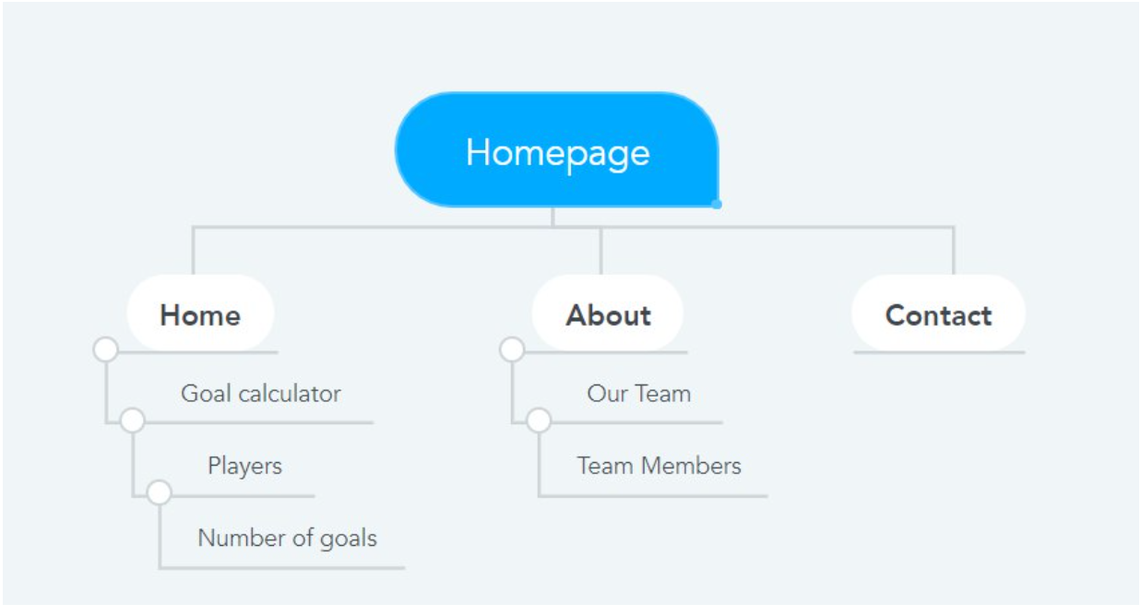

**Design**

Our most creative parts of our [brains](https://i.imgflip.com/3q4aod.png) were used to create our website design. In addition, we often used [bootstrap](https://bootstrap-4.ru/docs/4.6/getting-started/introduction/)(version:4.6*) for the “About” page.

The Homepage is a redesign of the website which we made on midterm. We did not use complicated and different graphic designs for our website because "Beauty is in simplicity". We tried to use neutral colors to make it look more aesthetically pleasing.

We also used a bootstrap grid to organize the photos. By the way, the photos of the people on the page were created by [artificial intelligence](https://thispersondoesnotexist.com). Maybe you will need it someday.

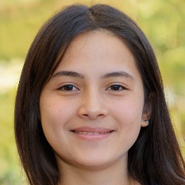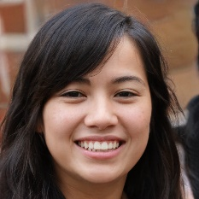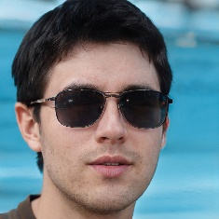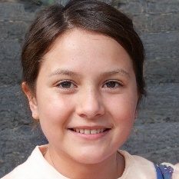

The only animations we used were a smooth scrolling effect and a hover effect where the tweet icon changes color when the cursor is on the icon. If you would like to know more about our design, you can have a look at our CSS code.